Online News Story

Deadly shooting strikes a Community College in Western New York
Charles A Gilbert, Associated Press • March 11, 2019
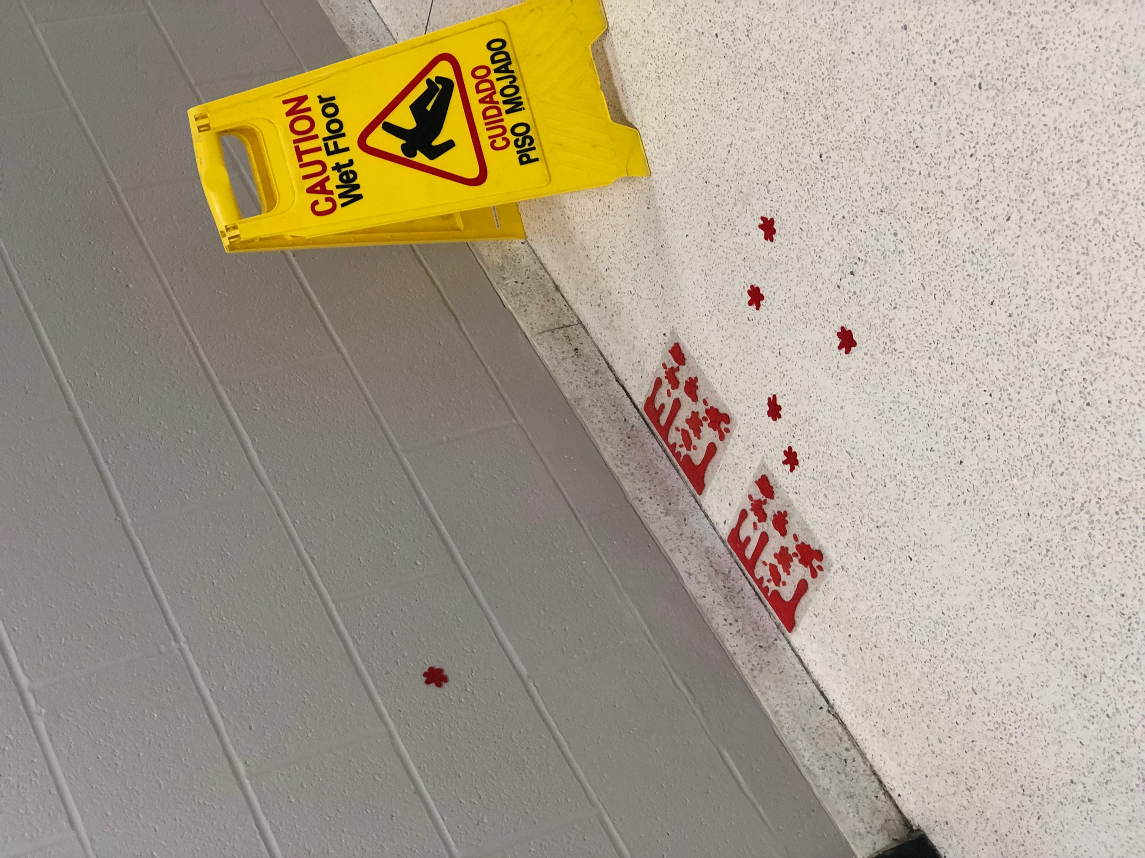

Shots rain out at SUNY Erie Community College leaving 2 students dead and one in stable condition, in Western New York – Orchard Park. March 11, 2019. (AP Photo/Charles A Gilbert)

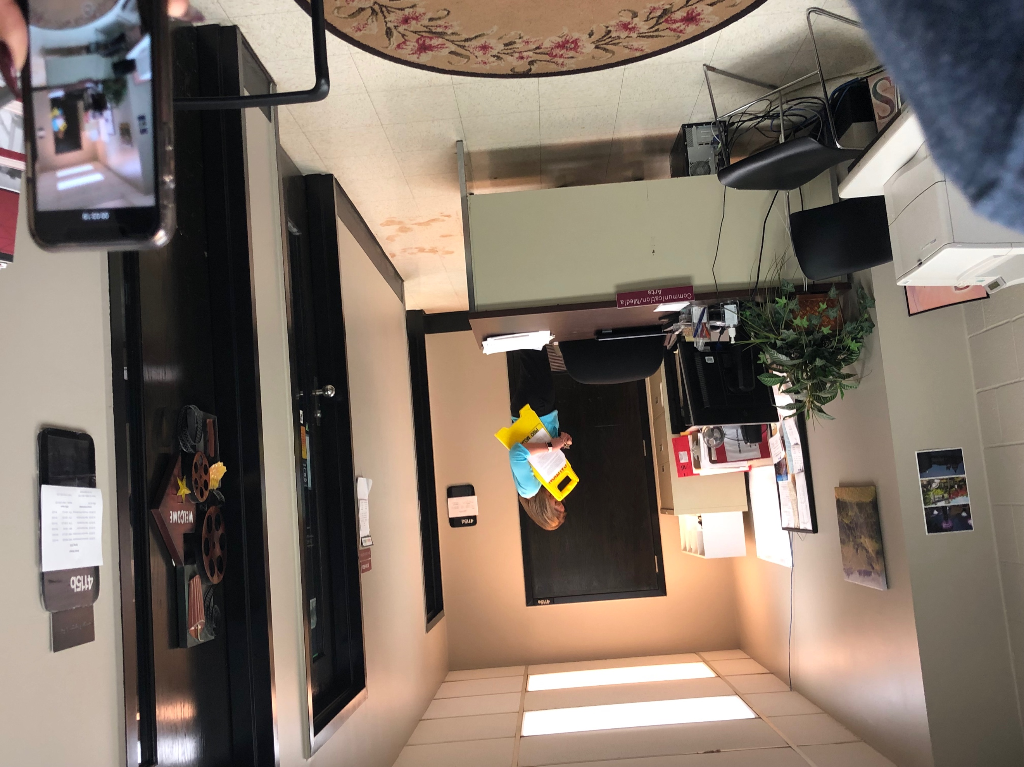
ORCHARD PARK, New York (AP) – The small town of Orchard Park is mourning today as tragedy struck Erie Community College, as 21-Year-Old Jason Downs entered the building and took the life of his ex-girlfriend Rachel Phillips – 19-years-old, wounding Kaitlyn Payman 26-years-old. It all began at 08:30 AM Monday morning when Downs arrived on the campus and entered building four. From there Downs came and confronted Phillips as she was leaving class. The confrontation stemmed from the two recently breaking up, during the conversation things escalated and Phillips tried to walk away from Downs, but he kept following her. Video surveillance shows both Phillips walking away from Downs and Downs following. Payman a friend of Phillips stepped in to break up the argument; then it happened. At 08:55 AM outside of room 4114 Downs pulled a handgun from out of his coat and shot at Payman. Payman fell to the ground and Phillips tried to grab the gun from but Downs turned his attention now to Phillips and struck her three times. Security made their way to the scene and Downs turned the gun on his-self killing him. Payman was taken to the local medicine center Erie County Medical Center in Buffalo, NY where she was treated for critical injuries but is in stable condition.

Lori Waleszczak a secretary at the school detailed the events as “So unexpected and it felt like I couldn’t breathe”. Once Downs fired the shots striking Payman and then killing Phillips; Waleszczak gathered as much students as she could and brought them into her office, close the office door and call for help. Waleszczak managed to call security despite being extremely scared and her hands shaking she managed to call and get ahold of Mark Hanzly a security guard at the school; stated to Waleszczak that there were aware of the situation and security guards were on their way. Waleszczak feared that Downs was coming for them next.
The office of Lori Waleszczak (AP Photo/ Charles A Gilbert)

This is the first time this small community college that holds 12,000 students with 50 educational programs and 15 certificate programs have had a tragedy affect their school. Having three campus locations throughout Western New York Erie
The office of Lori Waleszczak (AP Photo/ Charles A Gilbert)

Community College is a high-quality school at a low cost with afford tuition. Each building is under video surveillance with 15 building guards on the campus where this event took place, all of the guards were dispatched to building 4 once the first shot was fired. It takes one minute to get from building 5 where the guards office is to building 4 where the shooting took place. The guards acted quickly and sealed off the area and had building guards posted at all exits. A big problem that the school had was getting the information about the shooting to those who were on their way to the school. Erie Community College has and alert system that provides up-to-date alerts to the students and staff on any events that is happening in the school such as school cancellations, delays or in this case shootings. Only half of the students are register for the alerts.

For more information about the school, the alerts and information regarding Rachel Phillips memorial that will be held on Wednesday there is a Hotline number. 716-851-1111.

For additional information or comments on this article please contact me at gilberca026@ecc.edu or leave a comment in the box below.

Comments:

